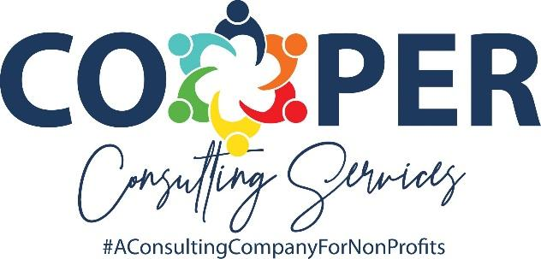
Before Your Plan Fails: A Leadership Capacity Assessment
This worksheet is designed to help nonprofit boards and executive leaders identify the gap between where their strategic plan wants to go — and whether their leadership capacity can get them there. Use it individually or as a team for a candid, honest conversation.

SECTION 1 | Your Strategic Plan Snapshot

Answer the following questions to ground yourself in your current plan before moving into the assessment.

Organization:

Plan Period:

1. What are your top 3 strategic priorities for this plan period?
Priority 1:

Priority 2:

Priority 3:

2. What does success look like at the end of this plan period?
Success looks like:

3. What is the single biggest obstacle standing between you and plan success?
Biggest obstacle:

SECTION 2 | Leadership Capacity Assessment

Rate each statement honestly on a scale of 1–5. There are no right or wrong answers
.

1 = Strongly Disagree 2 = Disagree 3 = Neutral 4 = Agree 5 = Strongly Agree

Statement | 1  Strongly  Disagree | 2  Disagree | 3  Neutral | 4  Agree | 5  Strongly  Agree
Our Executive Director has the skills needed to drive our top strategic priorities. | ☐ | ☐ | ☐ | ☐ | ☐
Our ED effectively communicates the strategic plan to staff, board, and stakeholders. | ☐ | ☐ | ☐ | ☐ | ☐
Our ED demonstrates strong decision-making under pressure and ambiguity. | ☐ | ☐ | ☐ | ☐ | ☐
Our ED actively develops their own leadership capacity and seeks growth opportunities. | ☐ | ☐ | ☐ | ☐ | ☐
Our board provides meaningful oversight and accountability for plan execution. | ☐ | ☐ | ☐ | ☐ | ☐
Board members understand their governance role versus the ED's management role. | ☐ | ☐ | ☐ | ☐ | ☐
Our board has the skills and engagement to support the organization's strategic direction. | ☐ | ☐ | ☐ | ☐ | ☐
There is strong, trust-based communication between our board and our ED. | ☐ | ☐ | ☐ | ☐ | ☐
Our leadership team (board + ED) operates with alignment around the plan's priorities. | ☐ | ☐ | ☐ | ☐ | ☐
We regularly assess whether our leadership capacity matches our strategic ambitions. | ☐ | ☐ | ☐ | ☐ | ☐

SCORING GUIDE: 40–50 = Strong alignment | 25–39 = Some gaps to address | 10–24 = Significant capacity investment needed
My Score:

SECTION 3 | Reflection & Gap Analysis

This is where real insight happens. Take your time with each question.

Where do you see the greatest distance between your plan’s ambition and your current leadership capacity?

Which of the 10 statements from Section 2 surfaced the most important issue for your organization? Why?

What is one leadership capacity investment — for your ED, your board, or both — that would move the needle most this year?

If leadership capacity remains unchanged, what is the realistic risk to your strategic plan?

Stephanie Cooper is the owner of Cooper Consulting Services, a nonprofit consulting company. She works with nonprofit organizations and their leaders to enhance their missions and transform their communities by providing executive leadership, fractional CEO services, strategic planning & implementation and board governance training. If you are interested in learning more, email stephanie@cooperconsulting.online.

