STEPHANIE COOPER, LMSW
BoardSource Certified Board Consultant | Nonprofit CEO | Professional Speaker
Enhancing Missions. Transforming Communities.
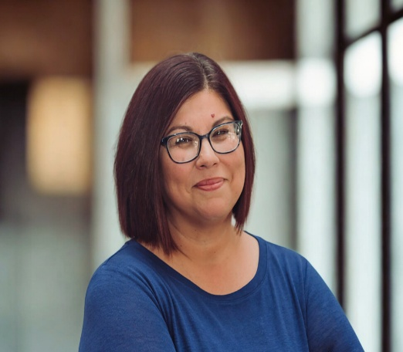 | ABOUT STEPHANIE  Stephanie Cooper brings more than 25 years of nonprofit leadership to every stage and engagement. As CEO of Douglass Community Services and founder of Cooper Consulting Services, LLC, she has spent her career at the intersection of governance, executive leadership, and community impact. As a Licensed Master Social Worker and BoardSource Certified Board Consultant, she delivers presentations that are honest, practical, and deeply rooted in the realities of nonprofit life.  Stephanie gives voice to the conversations others avoid — and makes space for the ones that actually matter.

SIGNATURE SPEAKING TOPICS
Board & Executive Director Leadership  Exploring what makes the board-ED partnership work, what breaks it down, and how both parties can lead with clarity, trust, and shared purpose. | Professional Identity Beyond Your Organization  How nonprofit leaders can build and own a professional identity that belongs to them — separate from their title, their organization, and their role. | Career Transition After Nonprofit Leadership  An honest, hopeful look at what comes next — navigating identity, purpose, and reinvention after a long nonprofit career.

WHAT AUDIENCES CAN EXPECT  - Real stories and practical insights drawn from 25+ years of nonprofit leadership  - A warm, approachable style that creates space for honest conversation  - Content grounded in both professional expertise and lived personal experience  - Takeaways audiences can apply immediately — not just concepts to think about  - A perspective shaped by executive leadership, board governance, and social work  AVAILABLE FOR  - Keynote presentations  - Breakout sessions & workshops  - Panel discussions & moderation  - Leadership retreats & board training days | CREDENTIALS & BACKGROUND  - BoardSource Certified Board Consultant  - Licensed Master Social Worker (LMSW)  - 25+ years of nonprofit sector leadership  - Active nonprofit CEO — Douglass Community Services  - Founder, Cooper Consulting Services, LLC  - Experienced governance trainer & strategic planning facilitator  - #IAmRemarkable Facilitator — 200+ participants across imposter syndrome, career & personal achievement workshops  - OHS Fellow — UCLA Anderson School of Management
READY TO BRING STEPHANIE TO YOUR EVENT?
info@cooperconsulting.online | cooperconsulting.online | 573-719-1456
PO Box 1061, Hannibal, MO 63401

